Rolling correlation: EURUSD and AUDUSD
Method 05 / daily log returns / windows 20, 60, 100 / Secondary tier

Study setup
Logical pair: EURUSD , AUDUSD
Broker symbols: EURUSD_i , AUDUSD_i
Tier: Secondary tier (secondary)
Snapshot: 2026-11-03_majors_alpari_D1
Timeframe: D1
Matched return window: 1999-01-05 to 2026-11-02 (UTC bar dates)
Matched return count (rows before rolling): 7201
Dropped unfinished last bar dated 2026-11-03 UTC after a tick-volume check against the prior complete day.
Rolling windows W: 20, 60, 100 trading days
Live-shaped n for each score: n = W (not the full history length)
Complete matched rows (CSV): EURUSD-AUDUSD_Rolling_D1.csv
Complete matched rows (HTML): EURUSD-AUDUSD_Rolling_D1_data.html

Method carried forward
Rolling Pearson r is computed on matched daily log returns of close, ln(close_t / close_t-1), in the broker quote direction. Quotes are not inverted. For each day t with a full window, r_W uses the last W matched return pairs ending at t. That live-shaped sample size is W (20, 60, or 100), not the full multi-year history. The first W-1 days have no score. r is symmetric under swap of the two symbols. A high |r| in one window does not prove cause, lead-lag, or a trading signal. Short windows are noisier; long windows are slower to reflect a break.
How to read a live day: after both daily candles close, the newest r_20 uses the last 20 matched log returns, r_60 the last 60, and r_100 the last 100. Compare those three to each other and to the full-sample baseline below. A break is when the short window moves far from the baseline or flips sign while the baseline was meaningful.

Full-sample Pearson baseline (method 01 v001)
Copied full-sample Pearson r for EURUSD-AUDUSD: 0.556324. This is a historical average link, not the live state.

Rolling results
W | latest_r | mean | median | min | max | std | pct_|r|>=0.4 | pct_|r|>=0.7 | n_roll
20 | -0.003562 | 0.545319 | 0.606141 | -0.444352 | 0.952999 | 0.252543 | 74.76 | 32.89 | 7182
60 | 0.443604 | 0.547353 | 0.594888 | -0.197798 | 0.8839 | 0.199919 | 78.02 | 24.56 | 7142
100 | 0.534255 | 0.54979 | 0.58853 | -0.098305 | 0.837018 | 0.180631 | 80.78 | 21.82 | 7102
n_roll is the number of days that had a complete window. pct_|r|>=0.4 and pct_|r|>=0.7 are the share of those days where the absolute rolling correlation cleared the threshold.

Conclusion
For EURUSD and AUDUSD, full-sample Pearson baseline r=0.5563. Latest rolling scores: r_20=-0.0036, r_60=0.4436, r_100=0.5343. Stability: moderate window-to-window variation. Agreement with baseline: r_20=-0.004 opposite sign vs baseline; r_60=0.444 near baseline; r_100=0.534 near baseline. Tier line: watch — short window has pulled away from the full-sample baseline; treat the link as unstable until windows re-align. This is a monitoring summary, not a trade signal.

What to look at in this file next time
1) Latest r_20 vs r_60 vs r_100 in the results table. 2) Whether short-window latest has the same sign as the baseline. 3) The rolling chart for stretches where |r| collapsed. 4) The CSV if you need a different chart later.

Charts
Rolling Pearson r (20 / 60 / 100)
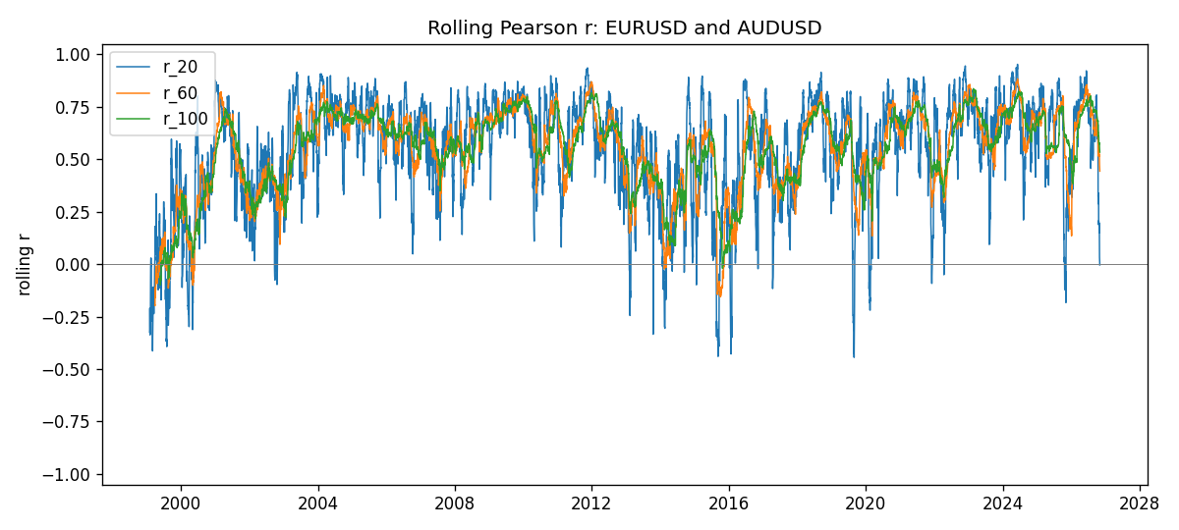
Daily closes

Daily log returns
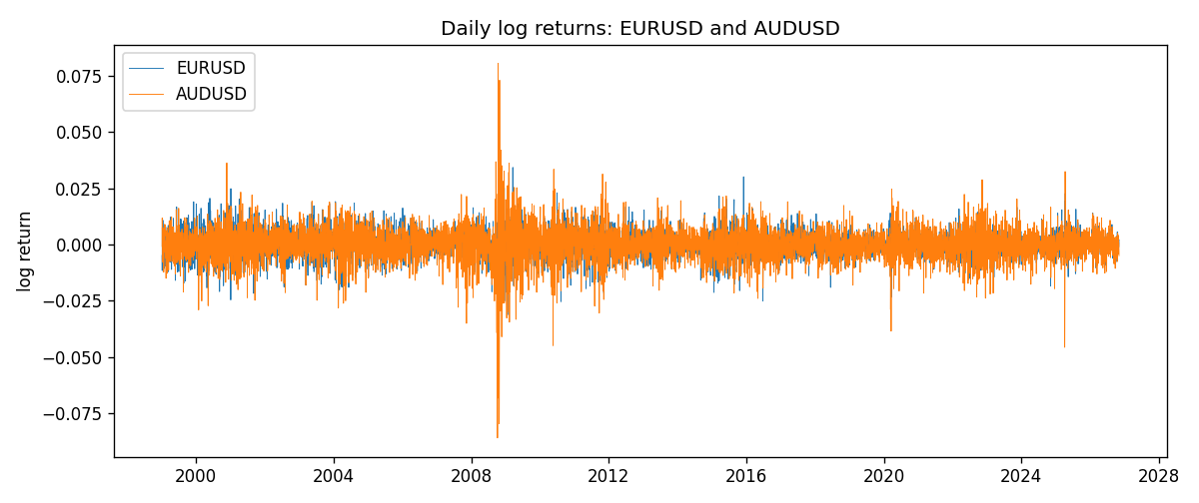

Data report
Every matched row with r_20, r_60, and r_100 is in the sibling CSV and HTML. This Word section holds column summaries and the first and last 15 rows of the rolling table.
Columns: time, EURUSD_close, AUDUSD_close, EURUSD_tick_volume, AUDUSD_tick_volume, EURUSD_log_return, AUDUSD_log_return, r_20, r_60, r_100
Column summaries
column | count | mean | std | min | 25% | 50% | 75% | max
EURUSD_close | 7201 | 1.18137 | 0.15084 | 0.8267 | 1.08601 | 1.16617 | 1.29395 | 1.5997
AUDUSD_close | 7201 | 0.752021 | 0.135241 | 0.4786 | 0.6612 | 0.73175 | 0.80916 | 1.10169
EURUSD_tick_volume | 7201 | 103005 | 173410 | 469 | 9389 | 52708 | 99441 | 1.47163e+06
AUDUSD_tick_volume | 7201 | 77347 | 138136 | 109 | 5434 | 43320 | 71320 | 1.23462e+06
EURUSD_log_return | 7201 | -7.54e-06 | 0.00580172 | -0.0312382 | -0.00324684 | 0 | 0.00325501 | 0.0343318
AUDUSD_log_return | 7201 | 2.459e-05 | 0.00754509 | -0.0860252 | -0.00385511 | 0.00028229 | 0.00415126 | 0.0806166
r_20 | 7182 | 0.545319 | 0.252543 | -0.444352 | 0.397558 | 0.606141 | 0.740346 | 0.952999
r_60 | 7142 | 0.547353 | 0.199919 | -0.197798 | 0.42541 | 0.594888 | 0.698187 | 0.8839
r_100 | 7102 | 0.54979 | 0.180631 | -0.0983049 | 0.44742 | 0.58853 | 0.689871 | 0.837018
First 15 matched rows
time | EURUSD_close | AUDUSD_close | EURUSD_log_return | AUDUSD_log_return | r_20 | r_60 | r_100
1999-01-05 | 1.1758 | 0.6215 | -0.00483605 | -0.000804182
1999-01-06 | 1.1623 | 0.6289 | -0.011548 | 0.0118364
1999-01-07 | 1.1712 | 0.6345 | 0.00762806 | 0.00886503
1999-01-08 | 1.1585 | 0.6347 | -0.0109028 | 0.000315159
1999-01-11 | 1.1503 | 0.6393 | -0.00710329 | 0.00722138
1999-01-12 | 1.1555 | 0.6362 | 0.00451037 | -0.00486085
1999-01-13 | 1.1681 | 0.6312 | 0.0108453 | -0.00789021
1999-01-14 | 1.1681 | 0.6295 | 0 | -0.00269692
1999-01-15 | 1.1563 | 0.634 | -0.0101532 | 0.0071231
1999-01-18 | 1.1605 | 0.6346 | 0.00362569 | 0.000945925
1999-01-19 | 1.1603 | 0.6392 | -0.000172354 | 0.00722252
1999-01-20 | 1.1566 | 0.64 | -0.00319393 | 0.00125078
1999-01-21 | 1.1601 | 0.6405 | 0.00302154 | 0.000780945
1999-01-22 | 1.1587 | 0.6327 | -0.00120752 | -0.0122527
1999-01-25 | 1.1552 | 0.6302 | -0.0030252 | -0.00395915
Last 15 matched rows
time | EURUSD_close | AUDUSD_close | EURUSD_log_return | AUDUSD_log_return | r_20 | r_60 | r_100
2026-10-13 | 1.11965 | 0.69821 | 0.0037403 | 0.00350077 | 0.666316 | 0.633324 | 0.683468
2026-10-14 | 1.11545 | 0.69715 | -0.00375823 | -0.00151932 | 0.621959 | 0.634884 | 0.684984
2026-10-15 | 1.12172 | 0.69191 | 0.00560531 | -0.00754471 | 0.321526 | 0.533059 | 0.625337
2026-10-16 | 1.12371 | 0.69426 | 0.00177249 | 0.00339064 | 0.340081 | 0.539857 | 0.626794
2026-10-19 | 1.12086 | 0.6978 | -0.00253946 | 0.005086 | 0.287621 | 0.514941 | 0.609307
2026-10-20 | 1.12354 | 0.70022 | 0.00238817 | 0.00346204 | 0.324416 | 0.529419 | 0.613824
2026-10-21 | 1.12318 | 0.70275 | -0.000320467 | 0.00360664 | 0.190602 | 0.583628 | 0.608813
2026-10-22 | 1.12139 | 0.70186 | -0.00159496 | -0.00126726 | 0.207699 | 0.54911 | 0.609047
2026-10-23 | 1.11989 | 0.70353 | -0.00133852 | 0.00237657 | 0.186367 | 0.542181 | 0.575954
2026-10-26 | 1.11735 | 0.70128 | -0.00227066 | -0.00320328 | 0.196751 | 0.539726 | 0.578377
2026-10-27 | 1.11272 | 0.70245 | -0.00415234 | 0.00166699 | 0.14963 | 0.514795 | 0.572252
2026-10-28 | 1.1152 | 0.70533 | 0.00222629 | 0.00409155 | 0.194881 | 0.520905 | 0.578876
2026-10-29 | 1.11772 | 0.70245 | 0.00225714 | -0.00409155 | 0.0512695 | 0.489352 | 0.554432
2026-10-30 | 1.11644 | 0.70316 | -0.00114584 | 0.00101024 | 0.0346401 | 0.473929 | 0.55335
2026-11-02 | 1.11881 | 0.69971 | 0.00212057 | -0.0049185 | -0.00356203 | 0.443604 | 0.534255

